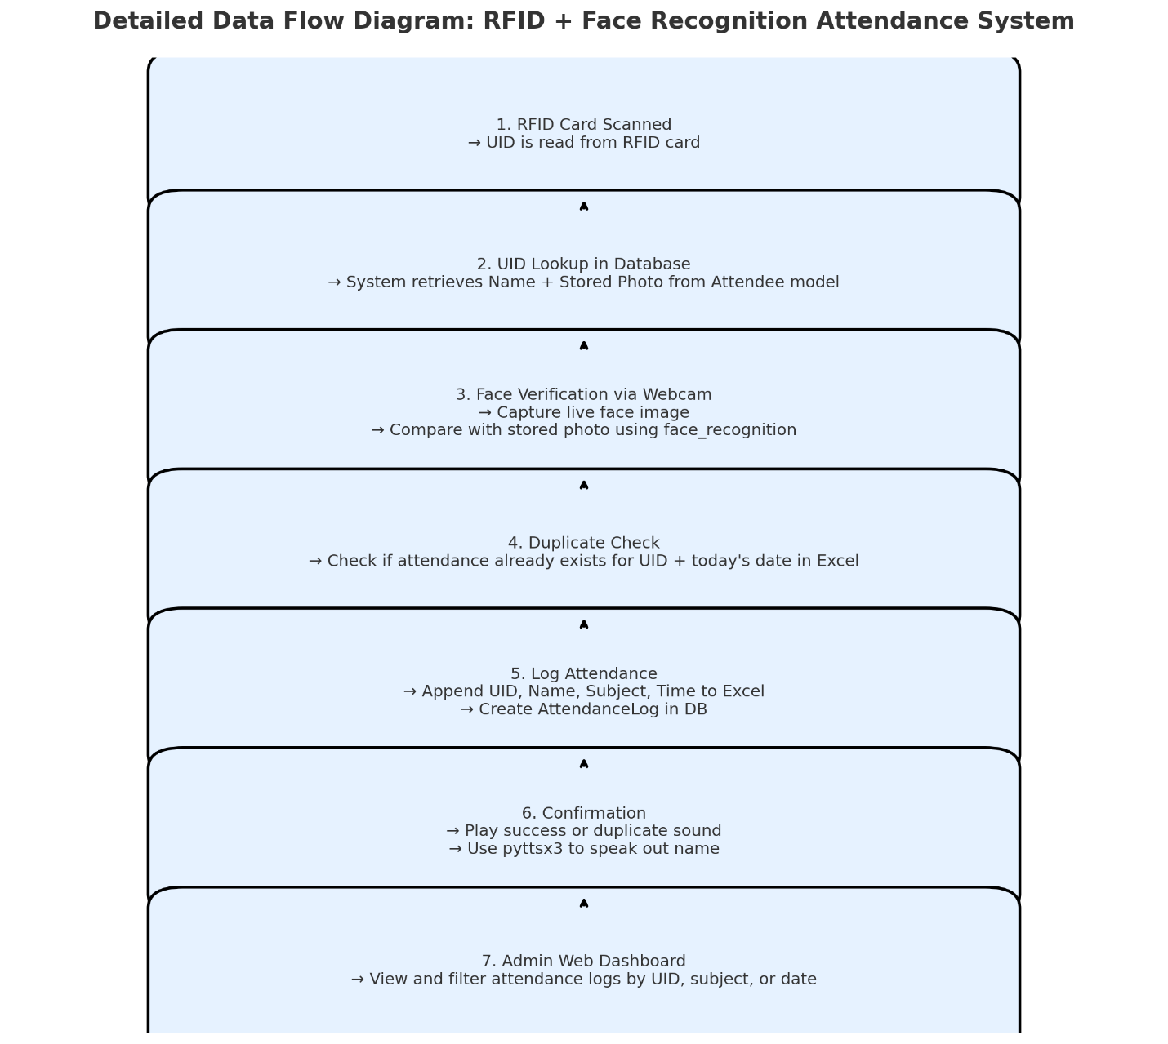

**Data Flow: RFID + Face Recognition Attendance System**

**STEP 1: RFID Card is Scanned**

The student taps their RFID card on the reader. The reader sends the UID (Unique ID) through a serial port to your Python program (rfid_reader.py).

**STEP 2: Look Up the Student in the Database**

The UID is searched in the Django database (Attendee model). If a match is found, their name and photo are retrieved.

**STEP 3: Face Verification via Webcam**

The webcam is turned on. A frame is captured and compared with the stored photo using face_recognition. If matched, continue. If not, stop and say: 'Face not recognized.'

**STEP 4: Check for Duplicate Attendance**

The attendance_logger.py checks if the UID for today's date is already present in the Excel sheet. If yes, it plays a duplicate sound and stops.

**STEP 5: Log Attendance (if not duplicate)**

A new row is added to the Excel file with UID, Name, Subject, and Time. A new AttendanceLog object is also saved to the database.

**STEP 6: Confirmation**

Plays a success sound and uses pyttsx3 to say: 'Attendance marked for [Name]'.

Optional Web Interface

Admins can view and filter logs on the dashboard page (`/dashboard/`).

Files Involved in the Flow

|  |  |
| --- | --- |
| **Stage** | **File Involved** |
| **RFID Reading** | **rfid_reader.py (serial input)** |
| **DB Lookup** | **models.py, views.py** |
| **Face Matching** | **face_recognition_script.py** |
| **Attendance Logging** | **attendance_logger.py** |
| **Feedback (Sound/TTS)** | **rfid_reader.py + static/sounds** |
| **Excel Management** | **attendance_logger.py** |
| **Web Display** | **views.py, dashboard.html** |